Relationship of CACHI with other State and Federal Initiatives

There are a number of health system transformation efforts currently underway or launching concurrently with CACHI. For example, the recently-approved section 1115, Medi-Cal 2020, includes a number of initiatives, such as the Public Hospital Redesign and Incentives in Medi-Cal (PRIME) program and the Whole Person Care (WPC) pilot program, while the Health Homes program under section 2703 of the Affordable Care Act will begin implementation on a rolling basis during 2016. In addition, in early January, the Centers for Medicare and Medicaid Services released a $157 million funding opportunity for Accountable Health Communities (AHC), which seek to connect health care delivery systems with health-related community and social services.

These initiatives have many aspects in common. For example, they recognize that there are numerous contributors to ill health, many of which exist outside of the health care system, and seek to promote greater integration and collaboration among health care and other providers. However, these initiatives also use a variety of approaches and may target different populations, geographic areas, and systems of providers.

In order to help applicants assess potential areas of alignment and how parts of some—or all—of the initiatives could be integrated within a community, we have prepared the following template. The matrix may help potential CACHI applicants identify how different revenue streams could be braided together as well as how various interventions that are being implemented through the WPC or AHC, for example, could also be part of a mutually reinforcing portfolio of interventions under the ACH.

Applicants are encouraged to fill out the matrix with regard to their particular communities and any of these (or other) initiatives that they may be involved with.

In order to assist with this process, attached please see 1) a diagram (below) showing the relationship between the populations and services associated with several of the initiatives and 2) of a detailed comparison of the California Accountable Communities for Health model with the CMMI Accountable Health Community program (attachment).

 | Accountable Communities for Health | Health Home  Section 2703 | 1115 Waiver:  Whole Person Care Pilot | Prevention First, PICH, REACH, etc | CMMI Accountable Health Communities | Other (e.g., Drug Medi-Cal Organized Delivery System)
1. Goal of your program or proposal

2. Structure and governance
- Presence/ absence of backbone
- Lead applicant
- Governance agreements
- Staffing
3. Partnerships
- Health care
- Public health or other govt.
- Other agencies

4. Geographic area
- Size/boundary

5. Selected health issue or condition
- Target population, if any

6. Intervention(s)/ program/
approach

7. Data sharing
- Program needs

8. Annual funding
- Use of funding
- Duration of funding

9. Metrics/ Outcomes

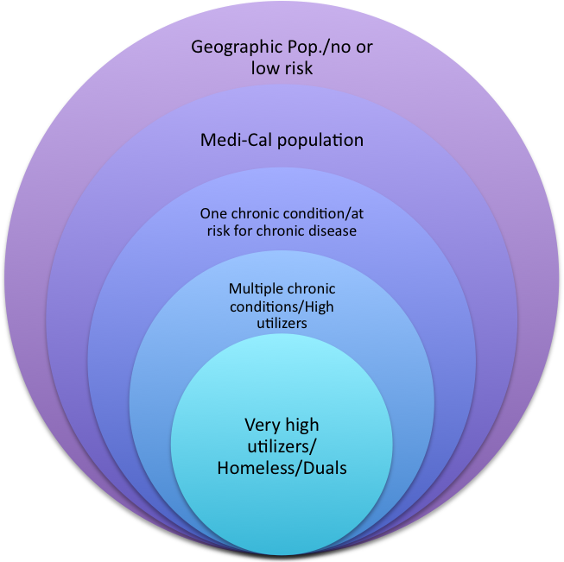
2-17-16
Health Homes for
Patients with Complex
Needs; Duals demon-
strations
Accountable Communities
For Health
1115 Waiver Whole
Person Care
Pilots

CMMI Accountable Health
Communities
Prevention-oriented policy, environment & systems
Linkage and referrals to social services and community supports
Care coordination, intensive care
management
Services
Initiative
Population

